Static Structural Analysis of the 3.0 Gen Eco-Marathon Vehicle Top Shell

Imperial College London – Imperial Eco-Marathon Team

# 1. Project Overview

Conducted finite element analysis (FEA) using ANSYS ACP(Pre) and Static Structural modules to assess the stiffness and safety of the carbon-fiber composite top shell under structural loads.

# 2. Objectives

Evaluate the structural response of the top-opening door section of the carbon-fiber top shell under localized loading representative of driver entry/exit.

- Validate the design can withstand concentrated forces   
- Check maximum deformation.  
- Identify high-stress regions to guide structural reinforcement.

# 3. Methodology

## ACP(Pre) – Composite Definition

Workflow:

1. Define material in Engineering data
2. Create Fabrics (Define thickness of carbon layer)
3. Create Stackups (Layers of carbon fibre with different orientations)
4. Define element sets to help create oriented selection sets
5. Define necessary rosettes to be used as fibre reference directions in oriented selection sets
6. Create Orientation selection set for components sharing the same fibre definition
7. Apply Stackup materials by creating modelling groups

Figure . Tree view of all objects created for ACP(Pre) setup

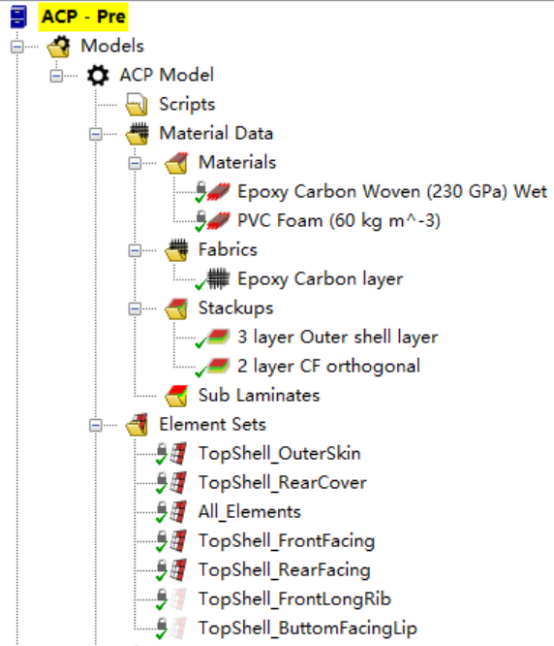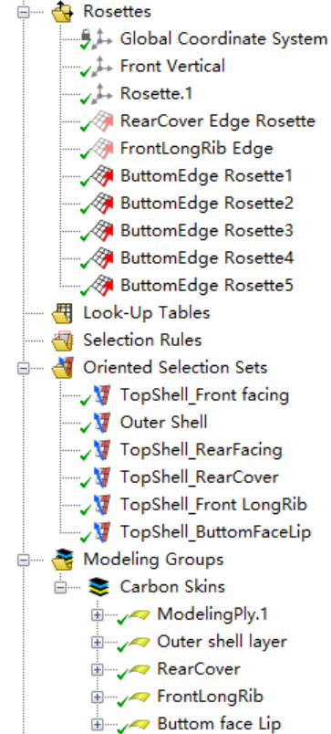

Oriented Selection Sets (OSS) Setup:

* In OSS, the **orientation direction** specifies layup direction. For example, the surfaces facing forward and backward will belong to different OSS to correctly define the layup direction.

Figure . Forward and backward facing orientation directions

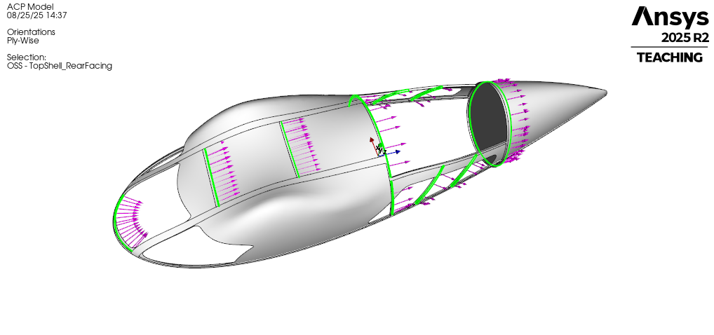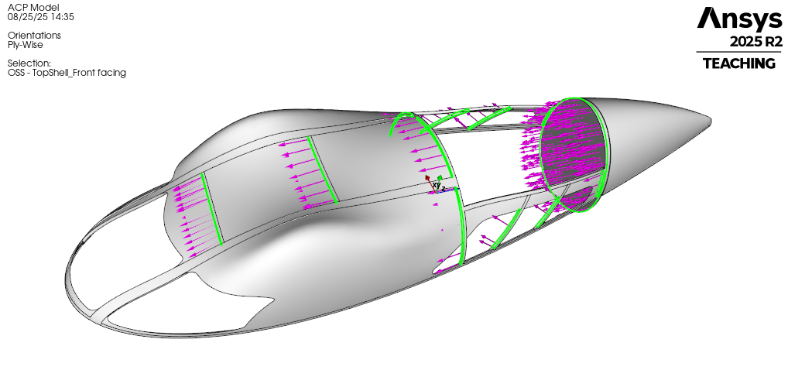

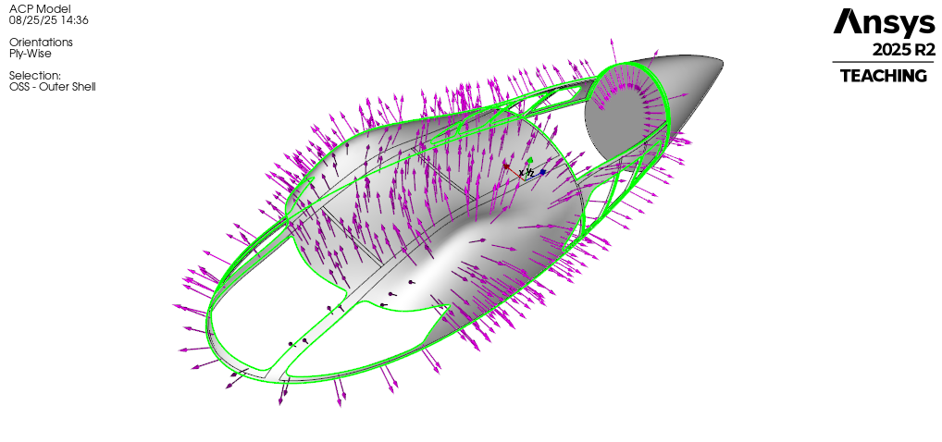

Figure .Outer shell skin layup directions

* In OSS, **reference direction** (as specified by rosette) defines fibre direction

Figure . Image shows the direction which fibre aligns (the 0 degree and 90-degree references)

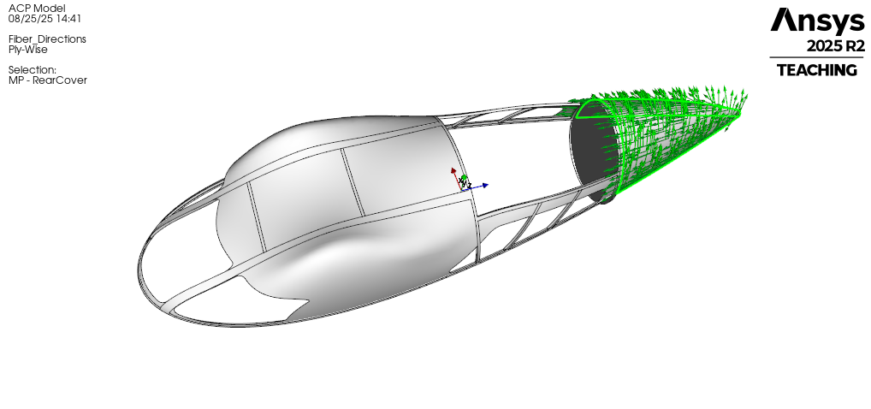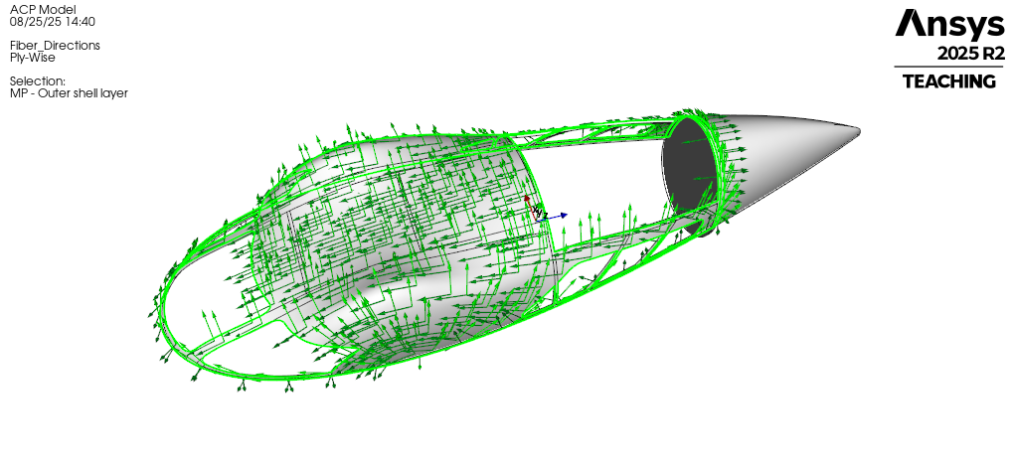

## Mechanical Model

* The mechanical model contains solid geometry that represents PVC foam of the composite structure.
* Generate mesh using adaptive sizing to ensure mesh quality at different parts of the solid model and avoid over-refined mesh sizes.

卡通人物

AI 生成的内容可能不正确。

Figure . Mesh result of solid model

## Boundary Conditions (Static Structural)

•

[Insert boundary condition diagram here]

# 4. Results

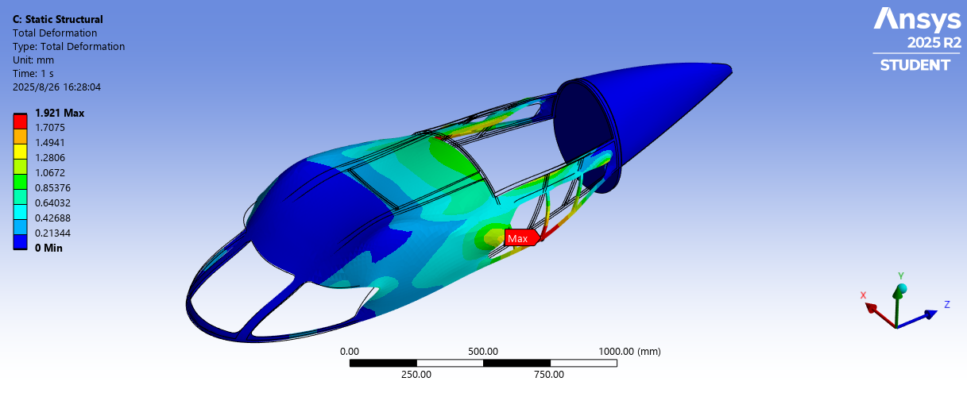

Caption: Maximum deformation = X mm (within tolerance).

[Insert stress distribution plot here]

Caption: Peak stress = Y MPa < Material strength (Z MPa).

[Insert annotated critical regions plot here]

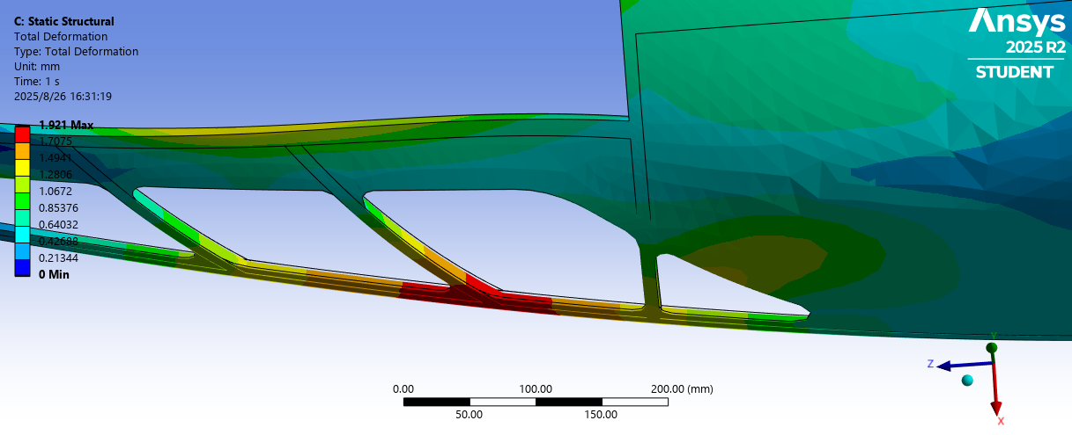

Caption: Identified hotspots requiring reinforcement.

# 5. Validation

• Mesh convergence check (table of element size vs. stress/displacement).

• Analytical check against laminate/shell theory.

• Safety factor verification.

# 6. Reflection & Engineering Impact

Optimized composite layup reduced shell mass by ~5% while maintaining stiffness.  
Developed proficiency in ACP(Pre), Static Structural, and composite modelling workflows.

# 7. Tools & Skills

Tools: ANSYS ACP(Pre), ANSYS Mechanical, Static Structural

Skills: FEA, composites modelling, load application, mesh convergence, results interpretation